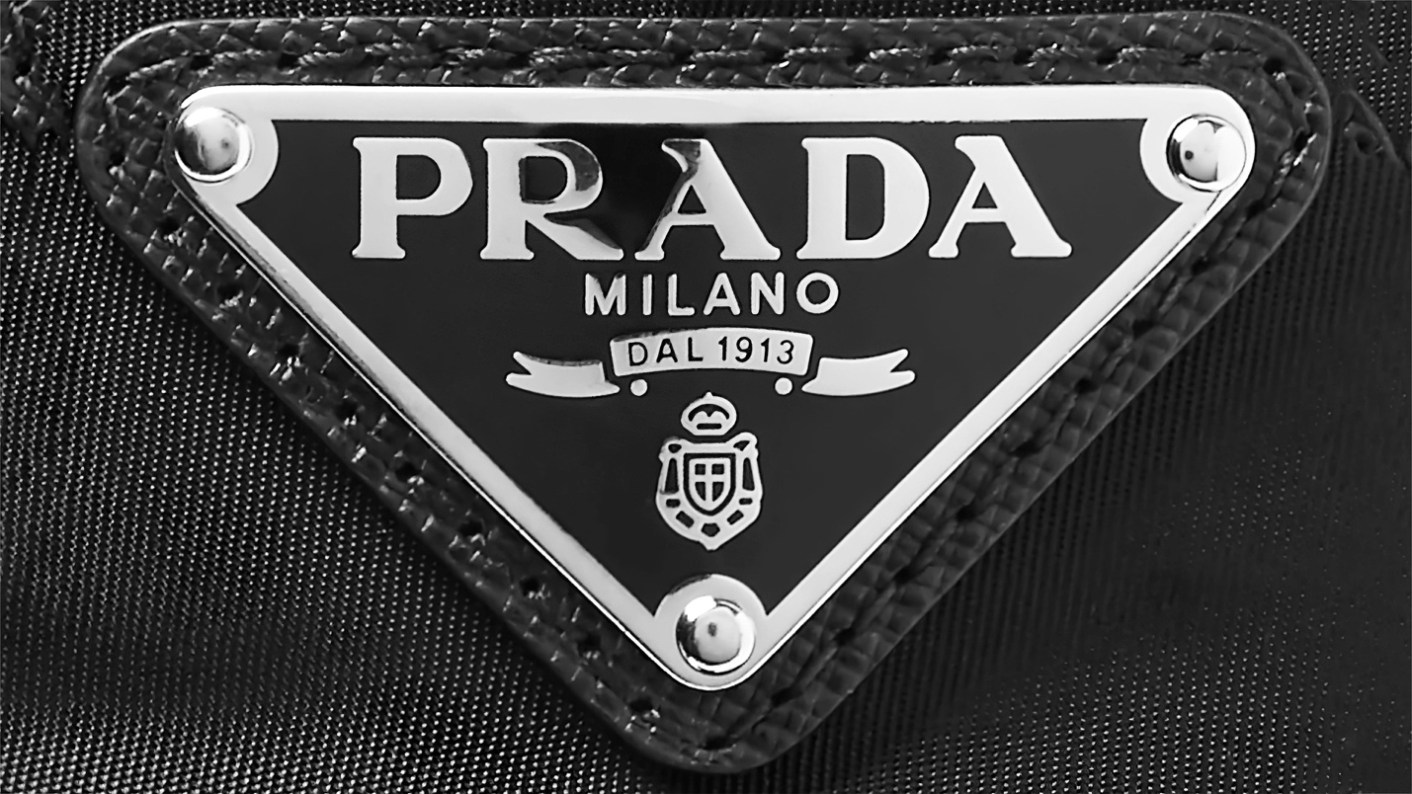

Symbole Sunglasses

**$ 230**

These acetate sunglasses with a pilot silhouette are characterized by their bold lines and Havana nuances. The geometric temples feature an iconographic interpretation of Prada's traditional triangle logo in a contrasting color.

